
YEAR 12 CHEMISTRY – 3BCHE

TEST 3

Redox and Electrochemical Cells

/ 40

Recommended time: 1 hour

Name: _____________________________________________________

Teacher: _____________________________________________________

MULTIPLE CHOICE QUESTION BOOKLET

This test is in three parts.

Part 1: is a multiple choice style test of fifteen (15) questions. Each question is of equal value and marks are not deducted if an answer is incorrect, SO ATTEMPT ALL QUESTIONS. Mark your choice of the most appropriate answer on the multiple choice answer sheet in the ANSWER BOOKLET. In the event that you wish to change your response, erase the incorrect answer and then mark the new choice in the space provided.

Part 2: is made up of 3 short and/or extended answer questions worth a total of 17 marks, and should be answered in the spaces provided in the ANSWER BOOKLET. The marks allocated for each question are shown at the end of each question.

Part 3: is made up of 1 calculation type question worth a total of 8 marks. The marks for each part of the question are shown. Write your answers in the spaces provided.

PLEASE DO NOT TURN THE PAGE UNTIL INSTRUCTED TO DO SO

PART 1: Multiple Choice

Mark your answers on the sheet provided. (15 marks)

1. Which one of the following reactions does not represent an oxidation-reduction reaction?

- 2MnO₄⁻(aq)+2H₂O()+ 3C₂O₄²⁻(aq) → 2MnO₂(aq) + 6CO₃²⁻(aq) + 4H⁺(aq)
- Cr₂O₇²⁻(aq) + H₂O() → 2CrO₄²⁻(aq) + 2H⁺(aq)
- 2Br₂(aq) + N₂H₅⁺(aq) → N₂(g) + 5H⁺(aq) + 4Br⁻(aq)
- 6I⁻(aq) + 14H⁺(aq) + Cr₂O₇²⁻(aq) → 3I₂(aq) + 7H₂O() + 2Cr³⁺(aq)

The next TWO questions refer to the following oxidation-reduction equation:

2 MnO₄¯ _{(aq)} + 5 H₂S_{(aq)} + 6 H⁺ _{(aq)}  2 Mn²⁺_{(aq)} + 5 S_{(s)} + 8 H₂O_{(l)}

2. The substance which has been oxidised in the above reaction is

    - MnO₄¯
    - H⁺
    - H₂S
    - S_{(s)}

3. The oxidation number of sulfur in this reaction has changed from

- –2 to 0
- +2 to 0
- 0 to –2
- 0 to +2

4. The reason that the half-reaction
2H⁺_{(aq)} + 2e‾ 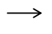 H_{2(g)} has an Eº value of 0.000 V is that:
  - It is most often used by scientists.

  - This is an arbitrarily set reference.

  - The value is known accurately.

  - Hydrogen is not a liquid at 25⁰C.
5. An electrochemical cell based on the following reaction has an E⁰ = 1.03 V

C₂ + 2V³⁺ + 2H₂O → 2VO²⁺ + 4H⁺ + 2C⁻

What is the standard reduction potential for the reaction where VO²⁺(aq) is converted to V³⁺ (aq)?

A. − 3.05 V

B. − 0.33V

C. + 0.33 V

D. + 3.05V

6. Which one of the following metals, when placed in a solution of copper(II) sulfate, would cause the solution to fade from blue to colourless?

  - Silver
  - Aluminium
  - Iron
  - Nickel

7. Which one of the following cells would you expect to produce the highest e.m.f.? (Assume all electrolytes to be 1.00 molL⁻¹ aqueous solutions.)

  - Mg/Mg²⁺ // Zn²⁺/Zn
  - Mg/Mg²⁺ // Fe²⁺/Fe
  - Mg/Mg²⁺ // Ni²⁺/Ni
  - Mg/Mg²⁺ // Cu²⁺/Cu

8. In the cell Zn/Zn²⁺ // Ag⁺/Ag, the species reduced is:

  - Zn
  - Zn²⁺
  - Ag⁺
  - Ag

Note: The next two (2) questions refer to the diagram and the equations below.
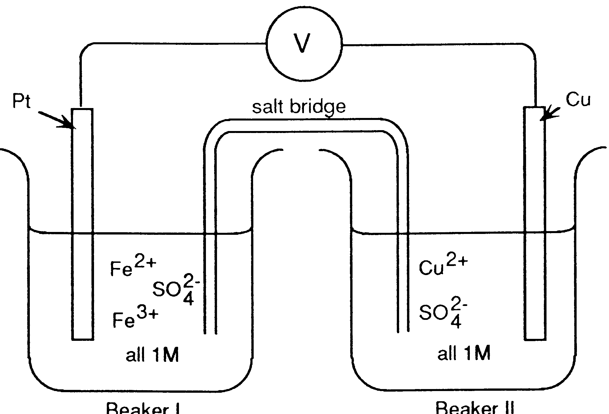
BEAKER I
BEAKER II

Note:
M = molL⁻¹

Fe³⁺ + e‾ Fe²⁺ E⁰ = 0.77 V
Cu²⁺ + 2e‾ Cu E⁰ = 0.34 V

9. If the salt bridge contained KNO₃ solution, the:
  - K⁺ ions move from beaker I and are replaced by Cu²⁺ ions.
  - NO₃‾ ions migrate into beaker I and are replaced by SO₄²‾ ions from
beaker II.
  - K⁺ ions move into beaker I and NO₃‾ ions move into beaker II.
  - K⁺ ions move into beaker II and NO₃‾ ions move into beaker I.

10. In the above cell the electrons will:
  - Flow in the wire from Cu to Pt.
  - Flow in the wire from Pt to Cu.
  - Not flow through the wire.
  - Flow through the salt bridge from Cu²⁺ to Fe²⁺

11. Which one of the following would oxidise Br⁻_{(aq)} but not C⁻_{(aq)} from a 1.0 molL⁻¹ solution containing both NaBr_{(aq)} and NaC_{(aq)}?

A. A solution containing acidified Cr₂O₇²⁻ _{(aq)}

B. A solution containing acidified H₂O_{2 (aq)}

C. An acidified solution of KMnO_{4 (aq)}

D. A concentrated solution of Cr(NO₃)_{3 (aq)}
12. Four metals Pb, x, y and z, were connected in pairs and the voltage was recorded.

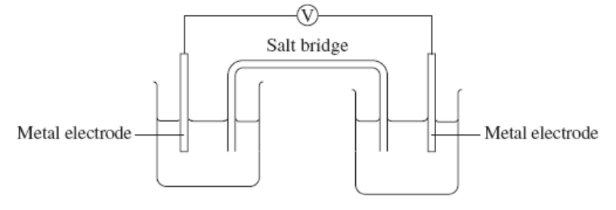
The results obtained are set out in the table below. List the metals from least easily oxidised to most easily oxidized.

Negative terminal | Positive terminal | Voltage (V)
Pb | x | 0.35
y | Pb | 1.10
z | Pb | 2.60

A. z, y, Pb, x

B. Pb, x, y, z

C. x, y, Pb, z

D. x, Pb, y, z

13. The following half-cell reaction equations have been taken from the Eº table:

Zn²⁺ + 2e‾ Zn E⁰ = -0.76 volt
Cd²⁺_{(aq)} + 2e‾ Cd E⁰ = -0.40 volt
The two metal electrodes are connected through a voltmeter and the solutions are connected by a salt bridge. The reading on the voltmeter would be:

  - 1.16 V
  - 0.76 V
  - 0.40 V
  - 0.36 V

14. Which one of the following equations represents a spontaneous redox reaction under standard conditions of 25ºC and 1.0 molL⁻¹ solutions?

A. Ag⁺_{(aq)} + I⁻_{(aq)} → AgI_{(s)}

B. 2Ag⁺_{(aq)} + Ni_{(s)} → 2Ag_{(s)} + Ni²⁺_{(aq)}

C. 3Ag⁺_{(aq)} + Au_{(s)} → 3Ag_{(s)} + Au³⁺_{(aq)}

D. 2Ag⁺_{(aq)} + Ni²⁺_{(aq)} → 2Ag_{(s)} + Ni_{(s)}

15. The purpose of a salt bridge in an electrochemical cell is to:

A. Separate the two half-cells physically, but provide a complete circuit
for the movement of electrons:
B. Separate the two half-cells physically, but allow the passage of ions.
C. Permit a migration of positive ions to the reducer half-cell only.
D. Permit a migration of positive ions to the oxidiser half-cell only.

END PART 1

Kiara College

Year 12 Chemistry Test 3

Multiple-Choice and Short Answer Booklet Total 40 marks

Name: _____________________________

Teacher: _____________________________

For each question, shade the box to indicate your answer.
Use only a blue or black pen to shade the boxes.

For example, if (b) is your answer: a  b  c  d 

If you make a mistake, place a cross through that square then shade your answer.
Do not erase or use correction fluid.

For example, if (b) is a mistake and (d) is your correct answer: a  b  c  d 

If you then want to use your first answer (b), cross out (d) and then circle (b).

a  b  c  d 
Marks will not be deducted for incorrect answers.
No marks will be given if more than one answer is completed for any question.

Questions 1-15

1 | a  b  c  d  |  | 9 | a  b  c  d 
2 | a  b  c  d  |  | 10 | a  b  c  d 
3 | a  b  c  d  |  | 11 | a  b  c  d 
4 | a  b  c  d  |  | 12 | a  b  c  d 
5 | a  b  c  d  |  | 13 | a  b  c  d 
6 | a  b  c  d  |  | 14 | a  b  c  d 
7 | a  b  c  d  |  | 15 | a  b  c  d 
8 | a  b  c  d 
(15 marks)
PART 2 : SHORT ANSWER [17 Marks]

Answer questions in the space provided. Note that not all questions carry equal marks.

1. This question refers to the diagram and information below. Use labels in the boxes on the diagram to show the

(a) anode;
(b) cathode;
(c) direction of the electron flow (use an arrow), and
(d) direction of flow of positive ions in the salt bridge (use an arrow).
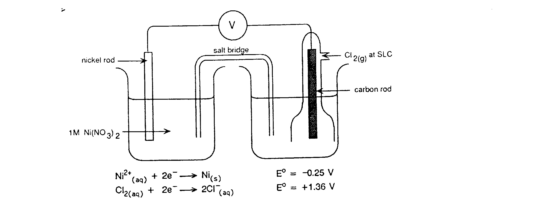
(4 marks)

Write the overall chemical equation for this electrochemical cell:

__________________________________________________________________

(1 mark)

2. A student was given freshly prepared solutions of iron(II) sulfate, sodium bromide, bromine water and acidified potassium permanganate. She carried out the tests shown in (a), (b) and (c) below. For each test to record any observed colour changes she may have seen, or write “NVR” if there is No Visible Reaction.

(a) Small amounts of the iron(II) sulfate solution and bromine water were mixed and shaken.

Observation: __

working space

(b) Small amounts of the iron(II) sulfate solution and potassium permanganate solution were mixed and shaken.

Observation: ________

working space

(c) Small amounts of potassium permanganate solution and sodium bromide solution were mixed and shaken.

Observation: _________

working space

(d) From these results, state which of the four solutions contained:

(i) the most powerful oxidant

(ii) the most powerful reductant
- marks)

- For each of the reactions below, complete the table that follows.
In each equation, state symbols are NOT required.

- When a solution containing potassium dichromate (K₂Cr₂O₇) and sulfuric acid is added to a solution of tellurium(IV) oxide (TeO₂), the mixture turns deep green which indicates that chromium(III) ions are produced. Every reduction must be accompanied by oxidation ,so the TeO₂ must have been oxidised. The only known higher oxidation state for Te is (+6), so presumably an ion similar to SO₄²⁻ is produced. Work out the equations below. (4 marks)

Reduction half-equation

Oxidation half-equation

Redox equation

- When a solution of potassium bromide (KBr) is added to a solution containing potassium bromate (KBrO₃) and sulfuric acid, the mixture turns orange which indicates that bromine is a reaction product. Work out the equations below. (4 marks)

Reduction half-equation

Oxidation half-equation

Redox equation

PART 3: CALCULATION [8 marks]

An experiment was carried out to determine the amount of active chlorine in a sample of household bleach. The chlorine is present in the form of sodium hypochlorite (NaCO).
The hypochlorite (CO-) is reacted with aqueous potassium iodide to produce iodine:

CO⁻ _{(aq)} + 2I⁻ _{(aq)} + 2H⁺ _{(aq)} → I_{2 (aq)} + C⁻ _{(aq)} + H₂O _{(aq)}

The liberated iodine produced is then titrated against sodium thiosulfate (Na₂S₂O₃):

I_{2 (aq)} + 2S₂O₃²⁻ _{(aq)} → 2I⁻ _{(aq)} + S₄O₆²⁻ _{(aq)}

In this experiment, 5.00 mL of the bleach solution was added to a 250.0 mL volumetric flask. Approximately 25 mL of 0.5 molL⁻¹ potassium iodide was added, along with approximately 25 mL of 2.00 molL⁻¹ sulfuric acid. The flask was filled to 250.0 mL with distilled water.
25.00 mL of the resulting solution was titrated against 0.100 molL⁻¹ sodium thiosulfate and required 15.50 mL of this solution to remove all the iodine produced.

- Calculate the amount (in moles) of thiosulfate ion that was required to react with the iodine in the titration flask.
(2 marks)

- Calculate the amount (in moles) of iodine in the titration flask and hence the amount of hypochlorite (in moles) that produced this iodine.
(2 marks)

(c) Calculate the amount (in moles) of hypochlorite in the 250.0 mL volumetric flask.
(2 marks)

(d) Calculate the concentration of sodium hypochlorite ions in the original bleach in:
(i) molL⁻¹ (ii) gL⁻¹ (2 marks)

END OF TEST


Look, if it was electric, could I do this?

